Key Concepts and Insights
- Cloud is Not Magic: Despite the perception that cloud services like Azure are inherently always available, physical infrastructure (data centers, racks, servers) can fail at multiple levels (node, rack, facility).
Disaster Recovery vs. High Availability:
  - High Availability (HA) focuses on resilience within a region, using features like availability zones, fault domains, and load balancers to protect against node or rack failures.
  - Disaster Recovery (DR) requires a greater geographical separation (often hundreds of miles) between regions to mitigate risks like natural disasters impacting entire regions.
Azure Regions and Paired Regions:
  - Azure has many regions worldwide, each consisting of multiple data centers.
  - Microsoft pairs regions to enhance resilience, coordinating updates so that paired regions do not receive simultaneous service updates, reducing the risk of simultaneous outages. Services like geo redundant storage, azure key vault, azure backup use paired regions.
Workload Architecture and State:
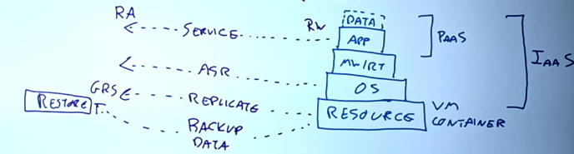
  - Workloads include multiple layers: infrastructure (VMs, containers), OS, middleware, app, and data.
  - Stateful components (e.g., databases, storage accounts) require replication (when low RPO needed) or backup to preserve data (when high RPO is fine). Stateless components (e.g., app front ends) can often be simply recreated.
- Recovery Objectives:
  - Recovery Point Objective (RPO): Maximum allowable data loss measured in time (e.g., 5 minutes, 1 hour).
  - Recovery Time Objective (RTO): Maximum allowable downtime before service restoration.
  - These objectives dictate the choice of DR strategy and cost.
Replication Strategies:
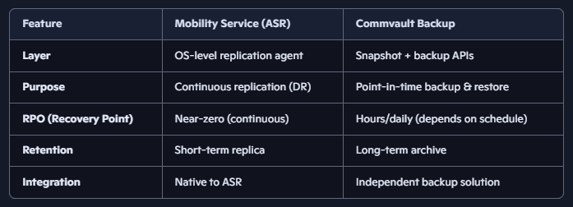
  - Application-level replication: Best performance and lowest data loss, fastest failover, typically asynchronous for cross-region scenarios due to latency effect on real-time app functioning if it was synchronous. Built into the service itself like always on (native) replication in SQL database.
  - OS-level replication: Tools like Azure Site Recovery capture changes at the OS level to replicate VMs – uses mobility service (agent) running inside OS which captures things that flow through the filesystem and volume driver - then replicated continuously to a target location (Azure or secondary site).
  - Resource-level replication: Native platform replication, such as Azure Storage Geo-Redundant Storage (GRS) for storage account.
  - Backup and restore: Useful for long RPO/RTO scenarios and simpler state recovery.
Resource cost decreases from app level towards Resource/Backup level, but failover time increases.
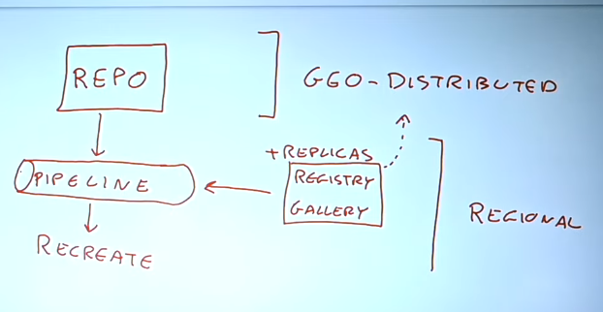
- Infrastructure as Code (IaC) and DevOps:
  - IaC templates and CI/CD pipelines enable quick recreation of stateless resources, critical for fast recovery and repeatability. Registries, image galleries which are used to recreate during pipeline are regional so should be replicated.
  - Repositories and pipelines are geo-distributed and resilient, preventing single-region dependencies.
Global vs Regional Services:
  - Certain Azure services like Azure AD, CDN, Azure Front Door, and Traffic Manager are globally distributed and inherently resilient, so do not require separate DR plans.
Traffic Routing and Failover:
  - Public IPs cannot be moved between regions; DNS updates (when mapped public ip changes) or geo-load balancers (Traffic Manager, Azure Front Door) are used to route users to the correct (and closest) region after failover. Geo-load balancers ensure application availability during failures by using health probes and automated DNS updates to redirect user traffic to healthy endpoints. When a primary region fails, these services automatically failover to a secondary region, providing continuous application access for user.
  - DNS caching (Time to live TTL – how much time a dns record is cached before requesting fresh copy from authoritative server) and client retry logic (multiple dns records may be returned corresponding to separate public ip from different regions having the replicated service, and client tries them to see which one works) affect failover responsiveness.
  - Internal/private IP (for internal facing apps) failover solutions require network virtual appliances as Azure’s global load balancer does not support private IPs yet.
Recovery/Failover Orchestration:
  - Azure Site Recovery provides recovery plans to automate failover processes (e.g., VM failovers, scripts, database failovers), reducing human error during disasters.
Hybrid and Multi-cloud DR:
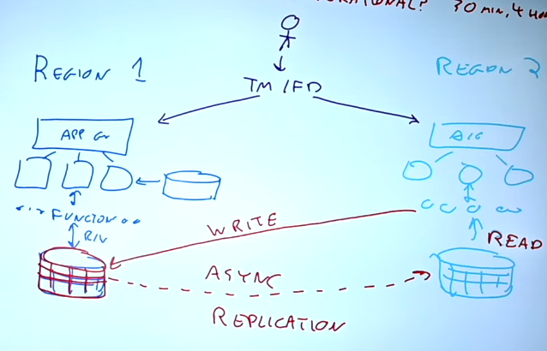
  - Azure can be used as a DR site for on-premises or other cloud workloads using replication, backup, and Azure Site Recovery.
- Active-Active Multi-Region Deployment:
  - Running workloads in multiple Azure regions simultaneously can improve availability and performance by reducing latency to users and providing automatic failover.
  - However, the database tier is often a limiting factor due to replication latency and consistency models, as most relational databases are single-write primary replicas.
Cost Considerations:
  - Higher levels of replication (app-level, active-active) increase costs due to duplicated compute resources. Backups and recreation strategies reduce cost but increase RTO and potential data loss.
  - DR environments should balance cost with business needs and recovery objectives.
- Ongoing DR Management:
  - DR planning is not a one-time effort: environments change, so DR plans must be updated and tested regularly. Active-active setups provide continuous testing and higher confidence in failover readiness.

Definitions Table
Term | Definition
Disaster Recovery (DR) | Strategies and processes to recover services and data after a regional or significant failure
High Availability (HA) | Design to minimize downtime within a region using redundancy and fault domains
Recovery Point Objective (RPO) | Maximum tolerable data loss measured in time before a disaster
Recovery Time Objective (RTO) | Maximum tolerable downtime before service is restored
Availability Zone (AZ) | Physically separate data centers within a region with independent power and networking
Asynchronous Replication | Data replication where writes are acknowledged locally and sent to secondary sites later, risking some data loss but improving performance
Synchronous Replication | Data replication where writes are acknowledged only after being written to multiple locations, minimizing data loss but increasing latency
Geo-Redundant Storage (GRS) | Azure storage replication that copies data asynchronously to a paired region
Infrastructure as Code (IaC) | Managing and provisioning infrastructure through code and automation tools
Azure Site Recovery (ASR) | Azure service that orchestrates replication, failover, and recovery of VMs and workloads
Traffic Manager | Azure DNS-based traffic load balancer for global failover and routing
Azure Front Door | Global HTTP(S) load balancer with SSL termination, routing, and failover

Summary of Best Practices for Azure Disaster Recovery
- Understand your workload layers and dependencies, especially where state resides.
- Define realistic RPO and RTO based on business needs and cost constraints.
- Use paired Azure regions to benefit from Microsoft’s update coordination and proximity.
- Choose the appropriate replication strategy (app-level, OS-level, resource-level, backup) based on RPO/RTO.
- Adopt Infrastructure as Code and DevOps pipelines to automate resource recreation and reduce recovery time.
- Use geo-load balancers (Traffic Manager, Azure Front Door) to handle client routing and failover.
- Implement Azure Site Recovery for orchestration and automation of failover processes.
- Regularly test and update your disaster recovery plans as your environment evolves.
- Consider active-active multi-region deployments for critical applications to improve availability and performance.
- Be mindful of database replication limitations and latency impacts on active-active architectures.
- Leverage Azure’s global services (Azure AD, CDN) which are inherently resilient and do not require regional DR planning.

